Fluorescence history
¹ George G. STOKES.
¹World Laboratory of Fluorescence, 1 Avenue des Champs Elysées, Paris, France.

Introduction
In 1852 George Gabriel Stokes described the ability of fluorspar and uranium glass to change invisible light beyond the violet end of the visible spectrum into blue light. He named this phenomenon fluorescence¹.

Materials and Methods
Mineral fluorite (calcium difluoride), containing traces of divalent europium, which serves as the fluorescent activator to emit blue light.

Results and Discussion
After an electron absorbs a high energy photon the system is excited electronically and vibrationally. The system relaxes vibrationally, and eventually fluoresces at a longer wavelength² (Fig.1).

Figure 1: Jablonsky diagram².
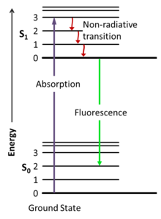

Conclusion
Fluorescence has many practical applications and occurs frequently in nature.

Bibliography
¹ B. Valeur, et all., A Brief History of Fluorescence and Phosphorescence before the Emergence of Quantum Theory. J. Chem. Educ., 2011, 88 (6), 731–738.
² A. Jabłoński, Efficiency of Anti-Stokes Fluorescence in Dyes. Nature, 1933, 131, 839-840.

